Safety and Security
Colombia

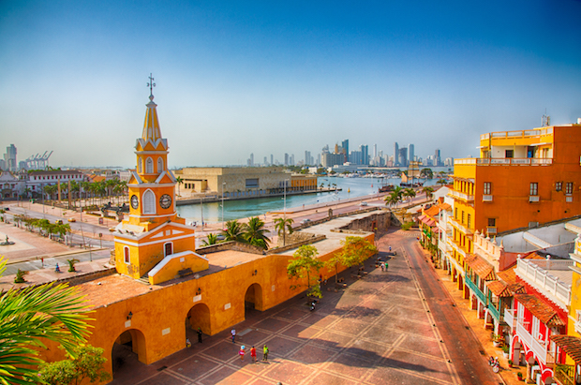

Country History
Alonso de Ojeda, first set foot in Colombia in 1499 declaring the land a Spanish colony. With the division and infighting between indigenous populations in Colombia, the Spanish had little resistance in setting up settlements throughout the country. As the Spanish colony grew, the Spanish colonizers brought in slaves from Africa to serve as the workforce and set up Cartegena as a slave trading port. Slavery, unfair taxes and duties prompted rebellion and brought about the rise of Simón Bolívar, who by 1812 became the face of the independence struggle. Bolivar was able to claim victory for Colombia, winning its independence on August 7th 1819. While civil war and drug violence have been prominent in the country’s past, great effort has been focused toward remedying that. President Juan Manuel Santos was recently awarded the Nobel Peace Prize for his efforts to pardon all FARC members, re-introduce them into society and end the country’s civil war.
Crime & Travel Advisories
Exercise increased caution in Colombia due to crime and terrorism. Some areas have increased risk.

Do not travel to:
- Arauca, Cauca (except Popayan), Chocó (except Nuquí), Nariño, and Norte de Santander (except Cucuta) departments due to crime and terrorism.
Reconsider travel to:
- Several departments throughout the country due to crime and terrorism.

Violent crime such as homicide, assault, and armed robbery is common. Organized criminal activities, such as extortion, robbery, and kidnapping for ransom, are widespread.

While the Colombian government signed a peace agreement with the Revolutionary Armed Forces of Colombia (FARC), some dissident groups refuse to demobilize.

The National Liberation Army (ELN) terrorist organization continues plotting possible attacks in Colombia. They may attack with little or no warning, targeting tourist locations, transportation hubs, markets/shopping malls, local government facilities, hotels, clubs, restaurants, places of worship, parks, major sporting and cultural events, educational institutions, airports, and other public areas.

Natural Disasters
Colombia is part of the Pacific Ring of Fire and Andean Volcanic Belt due to the collision of the South American Plate and the Nazca Plate. This produces an increased risk of earthquakes and volcanic eruptions. Due to the intensity of past natural disasters, Colombia has implemented a Disaster Risk Management System and in the event of a natural disaster, travelers should follow the instructions of authorities in the area that have been trained in this protocol.

Food and Drink
Listed below are traditional Colombian foods and drinks that you should expect to try during your time in Colombia:
Chicharon- These fried pork belly chips are considered a popular snack throughout Colombia
Arepas con huevo- Arepas with egg
Ajiaco- A popular soup made with chicken, 3 varieties of potatoes, and herbs

Aguardiente- Strong sugar cane based alcoholic drink
Aborrajado- is a dish of deep fried plantains stuffed with cheese

Local Laws/ Customs
- Carry your passport with you at all times
- Homosexuality is legal but not widely accepted, especially in rural areas
- Photographing of military or strategic government sites is not allowed
- Don’t get involved with illegal drugs of any kind. Colombian drug trafficking detection methods are sophisticated and anyone attempting to traffic drugs should expect to be arrested. Convictions will lead to severe penalties.
- Ayahuasca, or yage, is a traditional plant used in ‘spiritual cleansing’ ceremonies by indigenous communities in Colombia, primarily in Putamayo and the Amazon region. The yage ceremony typically involves the consumption of a brew containing dimethyltryptamine (DMT), an hallucinogenic drug. Consumption of this brew is not regulated and its interaction with existing medical conditions is not well understood. People have suffered serious illnesses and in some cases death after participating in these ceremonies.

Transportation
Methods of transportation in Colombia include train, bus, car, and plane. Be aware that Uber is illegal in Colombia and can result in heavy fines for both the driver and the passengers.
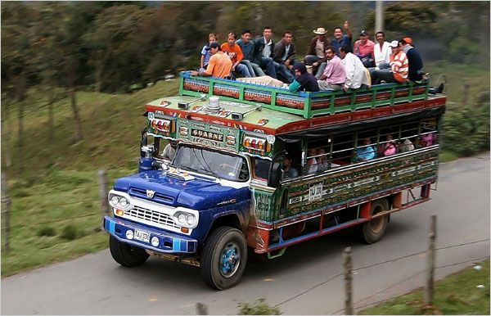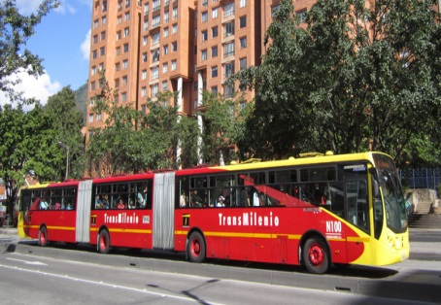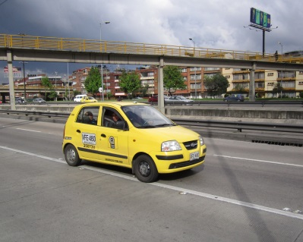
Immigration
Nationals of many countries, including Western Europe, the Americas, Japan, Australia, New Zealand and South Africa, don't need a visa. Otherwise, expect a nominal fee.
Prohibited Items
Items prohibited from entering and exiting Colombia include: chemicals, grain samples, food items, animal skins, seeds, plants, soil samples.

*For specific questions on what can/cannot be taken to and from Colombia, please call the United States Customs Border Control at 877-287-8667.
